VISION LINE  BELARUS, 220012  Minsk, 7 Surganova str. - 404  Tel/fax.: + 375 (0)17 284 01 89  Tel: + 375 (0)17 284 02 77  e-mail: visionline@mail.ru  web site: www.vl-by.com | 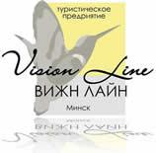 | ВИЖН ЛАЙН  БЕЛАРУСЬ,220012  Минск, ул. Сурганова 7 - 404  Тел/факс + 375 (0)17 284 01 89  Тел: + 375 (0)17 284 02 77  e-mail: visionline@mail.ru  web site: www.vl-by.com

Guided tour in Belarus
«MY NATIVE LAND»
Minsk – Khatyn - Berezinsky Biosphere Reserve –Zdrawneva - Vitebsk - Polotsk - Narochanski park - Grodno – August canal - Belovezhskaya Pushcha – Brest - Pinsk - Nesvizh - Mir - Minsk
14 days/ 13 nights

Day 1
Meeting of the group in the national airport “Minsk”. Transfer to Minsk.
Dinner in a Minsk café (Independently).
Accommodation in Hotel Belarus***. Overnight stay.

Day 2
Breakfast. Minsk sightseeing bus tour (City tour, 3 hours).
During the tour the tourists will see the most important landmarks of the city: XVII-XVIII century Catholic and Orthodox Cathedrals, Peter-and-Paul church, built in early 1600-ies, and the Red church constructed in the beginning of the XX century, the oldest street of Nemiga and the picturesque Historical City Center.
Lunch in a Minsk café. (Independently)
The second part of the tour around the historical city center, the city’s tourist gem – Troitskoye predmestie (the Trinity suburb) – an open-air museum, which includes stone buildings back to the XIX century, museums, antique gift shops, art galleries, coffee houses and restaurants.
Overnight stay in Hotel Belarus***.

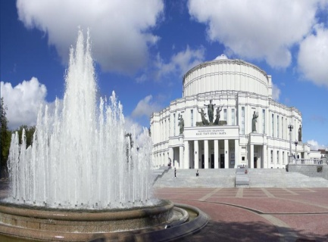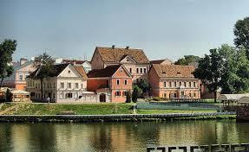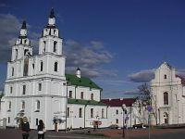

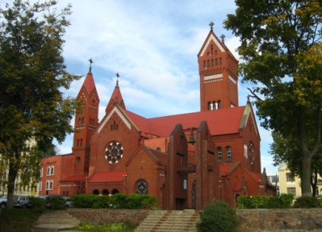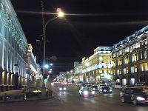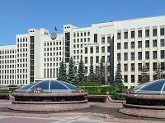

Day 3
Breakfast.
Departure to Biarezinski Biosphere Reserve - a unique natural complex, which includes an exceptional variety of different types of forests, meadows and swamps, a unique floodplain complex of the Berezina River with many large and small rivers and lakes.
On the way to Biarezinski Biosphere Reserve, visit to the Mound of Glory memorial complex - a memorial dedicated to the heroes of the Great Patriotic War.
.
Tour to Khatyn – a memorial complex dedicated to the victims of the Nazi terror in Belarus in 1941-1945. Khatyn has the only Cemetery of Villages in the world, the Wall of Memory with the names of concentration camps and the number of their victims.
Lunch in a café on the way to Biarezenski Reserve (Independently).
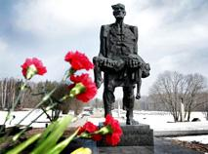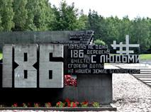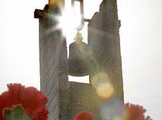
Arrival to Biarezinski Reserve.
Sightseeing tour of Biarezinski Reserve. Visit of the museum of Nature watching an exclusive film about the reserve, its history, territory, flora and fauna.
Departure to Vitebsk. Accommodation at the Eridan Hotel ***.
Dinner (Independently). Overnight stay.

Day 4
Breakfast.
Vitebsk sightseeing tour: Svyato-Uspenskiy Cathedral, The Church of the Annunciation, Embankment of River Vitba, Church of the Resurrection, The City Hall, The Governor's Palace, Kirov Bridge, Museum of Marc Chagall.
Lunch in a Vitebsk café. (Independently.)
Afternoon - excursion to the estate of the artist Ilya Repin "Zdravnevo", where from 1892 to 1902. the paintings “Autumn Bouquet”, “Hunter”, “Belarus”, “Moonlit Night”, etc. were created.
Visit to the house - museum of Marc Chagall or free time. The works of Marc Chagall can be seen in galleries in France, USA, Germany, Russia, Belarus, Switzerland and Israel. They honor the memory of the great artist and in his homeland: the house in Vitebsk, where the graphic artist lived for a long time, was turned into the Chagall house-museum. Lovers of the artist’s creativity to this day can personally see the place where the avant-garde artist created his masterpieces.
Dinner (Independently).
Overnight stay at the Eridan Hotel ***.
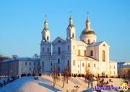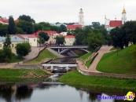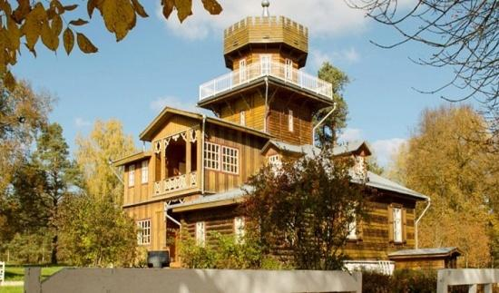

Day 5
Breakfast.
Departure to Polotsk city.
Polotsk sightseeing tour - an ancient center of the Belarusian lands.
The tourists will visit the Holy Wisdom Cathedral of the XVIII century, built above the remains the XI century cathedral, the cathedral dungeons, an organ recital, the functional Convent of the Saviour and St. Euphrosyne, which houses the hallows of the reverend Euphrosyne of Polotsk, and the Museum of book-printing in the ancient Theology monastery.
Lunch in Polotsk (Independently).
After lunch, continue the tour of Polotsk with free time for visiting to the Museum of book-printing in the ancient Theology monastery OR the Museum of traditional hand-weaving Lakelands.
Free time. Dinner in a restaurant or in a city cafe (Independently).
Accommodation at Hotel Dvina***.
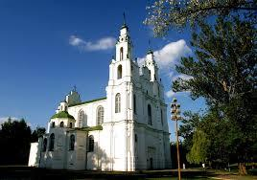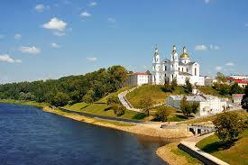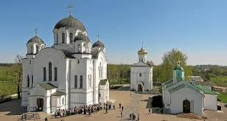

Day 6
Breakfast. A road trip to Narochanski park.
Narachansky Krai is a unique natural treasury and the largest resort region of Belarus. Picturesque landscapes, crystal-clear lakes and rivers, healing mineral springs attract visitors from all over the world. There are 43 lakes within the borders of the national park, about 48% of the park is covered with pine forests and birch groves. Flora is distinguished by a variety of mosses, lichens, mushrooms, algae. There are more than 1400 species of higher plants, 114 of which are listed in the Red Book of Belarus, including the most beautiful Belarusian orchid - Lady’s Slipper.
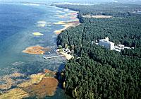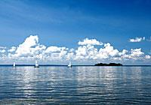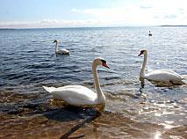
Naroch sightseeing tour upon arrival.
Lunch (Independently).
After lunch is the Blue Lakes route, lasting 4 hours. The distance from the hotel complex Naroch to the natural complex Blue Lakes is 40 km. The pedestrian part of the excursion is a 3 km route along a picturesque rugged terrain. Tourists get acquainted with several forest lakes from a large group of ponds, which are given the affectionate and warm name "Blue Lakes".
Accommodation in Wellness Center Chaika, located in the resort area of Lake Naroch, in one of the five specially protected areas in the country - the National Park "Narochansky”.
Free time. Overnight stay.

Day 7
Breakfast.
Departure to Grodno city.
On the way, a tour of the Grodno Territory with rides to the villages of Mikhalishki, Vornyany and Gervyaty is the pride of the Belarusian land and its “melody in stone”.
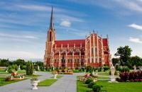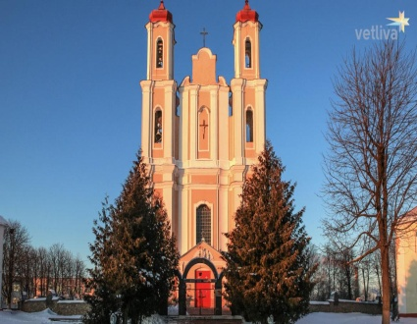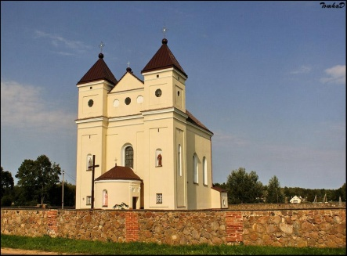

Lunch upon arrival (Independently).
Grodno sightseeing tour. Grodno is the only city in Belarus, which has the status of a landmark city – an open-air museum of architecture and city-building. During the excursion the tourists will see the monumental and elegant Cathedral Church of Grodno, Orthodox Church of the Nativity of the Blessed Virgin, villas of the nobles, numerous monasteries, brilliant architectural complexes of various epochs and styles, buildings by modernists and constructivists of the XX century, as well as visit the Castle Hill.
Accommodation at the Semashko Hotel ***. Overnight stay.
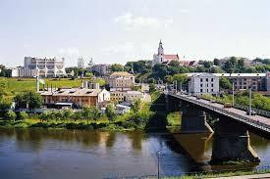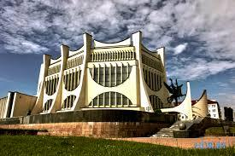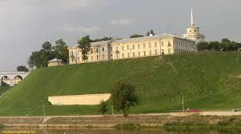

Day 8
Breakfast.
Free time to visit the Royal Gothic Castle XVIII (New Castle) or to walk around the historic part of Grodno.
Lunch in a cafe or restaurant in the city (on your own).
Lunch in a cafe or restaurant in the city (Independently).
Departure to the Augustow Canal - an outstanding hydraulic engineering structure of the 19th century, one of the largest canals in Europe, directly connecting the two large rivers Vistula and Neman, included in the preliminary UNESCO World Heritage List.
Boat trip along the Augustow Canal. After a boat trip, you are invited to visit the Pysanka Museum, where more than 600 Easter eggs, hand-painted, are collected OR a visit to the oldest Jewish cemetery in Belarus, in the village of Sopotskin. The first burials dated back to 1278.
Departure to Belovezhskaya Pushcha is one of the most important sights of Belarus.
Accommodation at the «Hotel Complex Kamenuki»
Dinner in a cafe (Independently).

Day 9
Breakfast.
A sightseeing tour of Belovezhskaya Pushcha with a visit to the bison enclosures.
Lunch in a cafe (Independently).
Excursion along the Ozernoye Koltso route - an ecological trail located in the recreation area of the southern part of the Belovezhskaya Pushcha National Park, which passes among forests that alternate with open sections of the right forest floodplain, swamps, small meadows and abandoned gardens. Duration 5 hours, length 5.8 km.
Belovezhskaya Pushcha is one of the four national parks of Belarus and one of the largest forest massifs in the plains in Europe which has been saved to the present day in a relatively undisturbed state. The most preserved site of old-aged plantations of the national park has been included in the list of the World Heritage of Humanity in 1992 by the UNESCO decision.
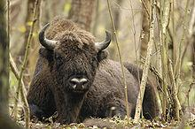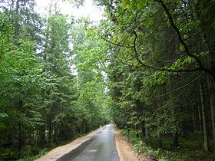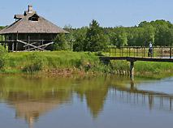
Accomodation in «Hotel Complex Kamenuki» .
Dinner in a cafe (Independently).
Day 10
Breakfast.
Departure to Brest.
Upon arrival, a sightseeing tour of Brest.
Brest is an ancient city on the border of Belarus and Poland (the first mention is dated back to
1019), has an ancient and eventful history. During the tour you will see architectural monuments of the Early Middle Ages, Polish churches, Orthodox churches, cozy streets and embankments, as well as the famous Brest Fortress - a fortified citadel built on the site of Brest castle in 1833.
Accommodation in Hotel Vesta*** situated in the center if Brest in 2 km from the Brest Fortress.
Lunch in a cafe. (Independently)
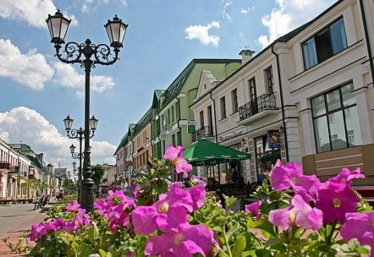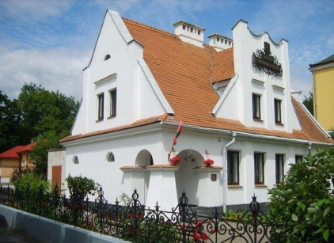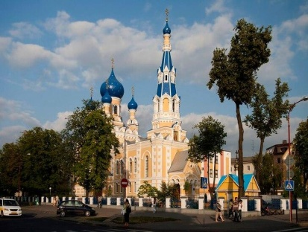

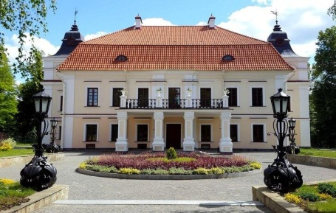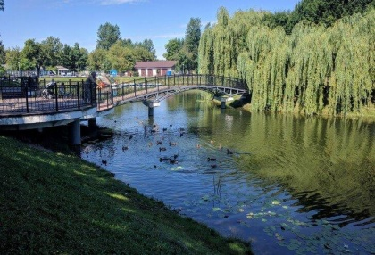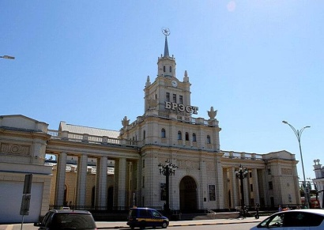
After Lunch, free time to visit Museum "Berestye" OR The Brest Fortress.
Museum "Berestye" - archaeological exhibition, founded in 1982 at the excavation site. The basis of the collection is finds discovered on the territory of the XIII century ancient settlement, including residential and outbuildings raised from a depth of 4 meters and restored according to historical appearance. You can learn a lot about the traditional way of life of the Slavs, see the objects that were in commonplace many centuries ago.
The Brest Fortress is a symbol of steadfastness and courage, which houses a museum complex dedicated to the events of World War II.
Dinner in a cafe (Independently). Free time.
Overnight stay in Hotel Vesta***

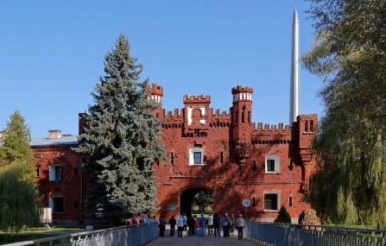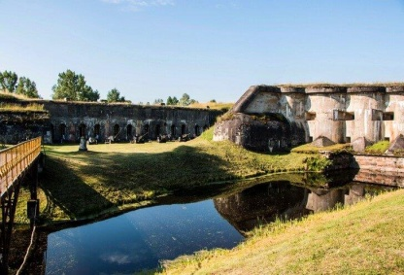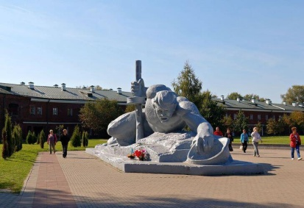

Day 11
Breakfast.
Departure to Pinsk - the cultural and industrial center of Polesie, the religious core of the country - the center of the Catholic and Orthodox dioceses and a significant Jewish community.
Upon arrival, a city tour: Jesuit Collegium, Franciscan Monastery and Church of the Assumption of the Blessed Virgin Mary, Varvara Church and Church of Karl Baromey, Butrimovich Palace, river station and piers of the old bridge, synagogue building, Horde House, Polessky Drama Theater, etc.
Lunch at the city cafe (Independently). Free time.
As an option - visit the Museum of Belarusian Polesie. Among the most memorable exhibits of the Museum of Belarusian Polesie is a stone cross, a sarcophagus from pink slate of the 12th century. The pride of the museum is its art gallery (more than 2,000 paintings), where canvases by I.K. Aivazovsky, V.M. Vasnetsova, I.I. Shishkin and others are exhibited. The main pearl of the gallery is a painting by I.K. Aivazovsky "The Sea", written in the middle of the XIX century.
Departure to Ezera Park Hotel, 35 km from the city of Pinsk, on the banks of the Pogost reservoir in a pine forest. Dinner at the cafe (Independently). Overnight stay at Ezera Park Hotel.
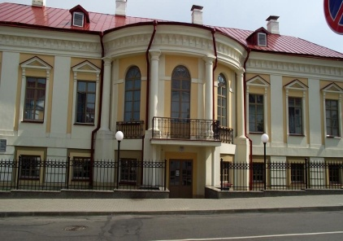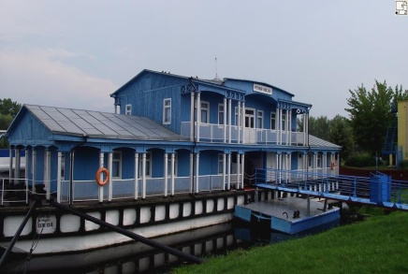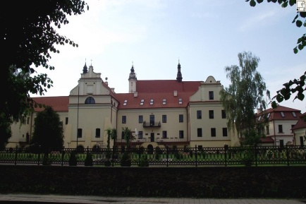

Day 12
Breakfast.
Departure to Minsk. On the way to Minsk visit to Mir town and Nesvizh town (120 km).
The Mir Castle is one the most precious landmarks of Belarus, included by the UNESCO into the World Cultural Heritage List. During the excursion you will visit the historical part of the town of Mir, the exhibition of the great Mir Castle, modernist-style shrine of the last owners of the Castle, the family of Svyatopolk-Mirsky princes.
During the excursion around the Palace and Parks Ensemble in Nesvizh you will learn the history
of the Radzivills, one of the most influential dynasties of the Grand Duchy of Lithuania and Polish-
Lithuanian Commonwealth (Rzeczpospolita), and walk around the great halls of the castle: the
Hunters’ hall, Ballroom, Portrait gallery, Fireplace room, Golden hall.
Upon arrival, accommodation at the hotel "Belarus" ***.
Dinner at the cafe (Independently). Free time. Overnight stay.

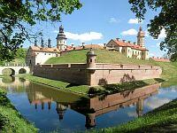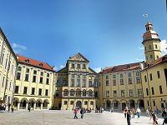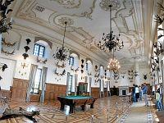

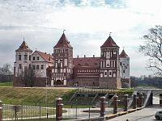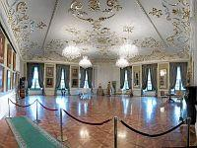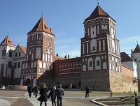

Day 13
Breakfast.
A visit to the State Museum of the History of the Great Patriotic War - the first in the world dedicated to the most bloody war of the twentieth century. Today it is one of the most significant and largest museums on the planet - along with the richest collections in Moscow, Kiev, New Orleans - which tell about the events of the Second World War.
Lunch at the city cafe (Independently). Free time.
Overnight at the Belarus Hotel***.

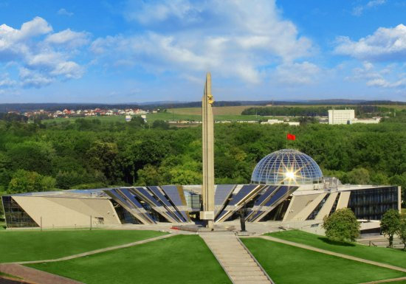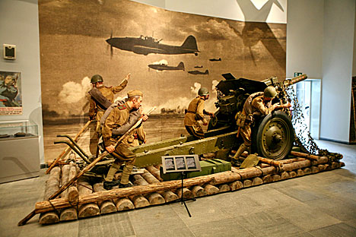

Day 14
Breakfast.
Departure to Minsk Airport.

INCLUDED

- 13 nights - BB in selected hotels:
4 nights (breakfast "buffet") in the hotel "Belarus" *** Minsk;
2 nights (continental breakfast) in the hotel "Eridan" *** Vitebsk;
1 night (continental breakfast) in the hotel "Dvina" *** Polotsk;
1 night (continental breakfast) in the recreation complex "The Seagull" Naroch;
1 night (breakfast "buffet") in the hotel "Semashko" *** Grodno
2 nights (continental breakfast) at the Hotel Complex Kamenuki Belovezhskaya Pushcha;
1 night (breakfast "buffet") in the hotel "Vesta" Brest;
1 night in the farmstead (continental breakfast) "Ezera Park Hotel", 35 km from Pinsk;
- transfer airport - hotel - airport;
- transport service along the route;
- excursion service according to the tour program with guides;
- excursion to the Barrow of Glory and to Khatyn;
- visit to the Berezinsky reserve and Museum of Nature in the Berezinsky reserve;
- visit to "Zdravnevo" where the museum-estate of I.Repin is located ;
- visit to St. Sophia Cathedral;
- sightseeing tour to the Narochansky park and the eco-route "Blue Lakes";
- Excursion to the Augustow Canal with a boat trip;
- visit to open-air cages with bison in Belovezhskaya Pushcha;
- eco-route “Lake Ring” in Belovezhskaya Pushcha;
- visit to the Nesvizh town and Mir town with excursion;
- accompaniment of the guide along the entire route;
- accomodation for the guide and the driver at the hotels along the route, excluding
accommodation in Minsk;
- 24/7 emergency and administrative backup services;
- company services charges, including tax.

NOT INCLUDED:

Entrance tickets and, if necessary, guide services to:
-Museum of Marc Chagall;
-House-Museum of I. Repin;
-Museum of Weaving and Museum of Printing;
-a concert of organ music in St. Sophia Cathedral in Polotsk;
-the Royal Gothic castle in Grodno;
-a visit to the Brest Fortress;
-the Berestye Museum in Brest;
-the Museum of Belarusian Polesye,
-the palace and park complex in Nesvizh, Mir Castle;
-the Second World War Museum;
- Lunches and dinners in a cafe or restaurant.

